http://tlc.howstuffworks.com/family/paper-gondolas.htm Make a paper gondola. Instructions for kids.
http://www.crayola.com/crafts/glide-along-a-venetian-canal-craft Make a scene from Venice
http://www.explore-italian-culture.com/gondola-driver.html#axzz2bsH65Yhh Information about Gondolas and Gondoliers
http://www.explore-italian-culture.com Something for everyone. Explore current culture as well as ancient culture.
http://www.gardenofpraise.com/art17.htm Great website for information on Leonardo da Vinci and his works.
http://www.enchantedlearning.com/artists/davinci/coloring This has several pages of Da Vinci art that can be colored.
http://www.kinderart.com/arthistory/inventionconvention.shtml Website has info on Da Vinci and some of his inventions. The activity is to design a machine that would make life easier.
http://ngm.nationalgeographic.com/2006/07/rome-ruins/rome-ruins-learn This site has lots of info for parents and teachers about ancient Rome.
http://kids.nationalgeographic.com/kids/places/find/italy NG for Kids website about Italy
http://kids.nationalgeographic.com/kids/search/?site=default_collection&client=default_frontend&proxystylesheet=default_frontend&output=xml_no_dtd&oe=utf-8&search=ancient+rome&btnG=&start=0&sort
Mama Lisa's World (children's songs and rhymes)
http://www.mamalisa.com/?p=824&t=ec&c=120

Italian for Kids
http://www.chillola.com/at/italian%20starter%20page.html

Kid’s blog on Italy:

World's Best Pizza
Posted By Stefan
Hi everyone. I'm in Rome, Italy where there is a lot of really cool "old stuff." In Rome, there is the Colosseum, which is where they used to have gladiators fights in ancient times. I learned that sometimes the gladiators would fight to the death. The ancient Romans liked to see blood and killing, but that was about two thousand years ago. They are really nice now and the Colosseum was almost completely destroyed because of an earthquake.
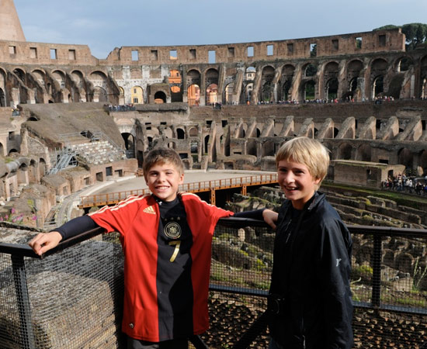
We went to another ancient building called the Pantheon. It was built about 2,000 years ago, but it's still in really good shape. At first it was a church, but then it was turned into a tomb. The huge domed roof of the Pantheon has a big open skylight so when it rains, the water comes right in. There's a drain in the middle of the floor so it doesn't flood. The skylight is also the only way that light gets into the building but it was also put there so that people's prayers could easily reach heaven.
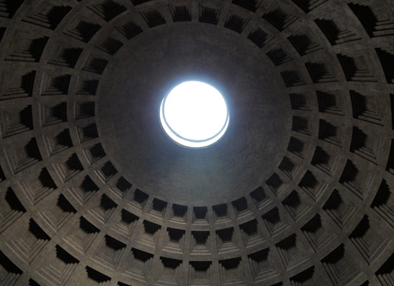We also went to the Vatican, which is where the Pope lives. The Vatican is surrounded by Rome but is actually its own country. They even have their own postal system and our guide told us that we should mail our postcards from there because they'd get to the U.S. much quicker then with the regular Italian mail.
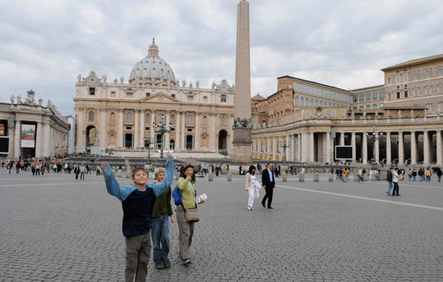The Vatican has one of the most famous churches in the world, St. Peter's Basilica, which was HUGE. Another really famous part of the Vatican is the Sistine Chapel, which is a much smaller church. The Sistine Chapel is so famous because over 500 years ago, the Popes wanted all the walls and even the ceiling painted by the best painters in Italy. The entire ceiling was painted by Michelangelo, showing stories from the Old Testament Bible. There were also paintings along both walls. In the front of the chapel was a huge painting called "The Last Judgment." Michelangelo also painted that, which I thought was really amazing. He's one of the best artists ever.
And last, but not least, the best thing you can get in Italy is THE PIZZA!!!!! The pizza was amazing in ... the best in the world and my absolute favorite. I should know, I've tried pizza in almost everyone country we've been to so far.

